**Fundamentals of Neural Networks**

**Assignment 1**

Abstract

To build a neural network using MATLAB to estimate the MPG (Miles per Gallon) based on the database provided which consists on the input variables and the target values.

**Software Design – 564**

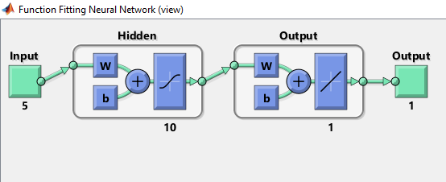

**Vaishak Ramesh Vellore**

**1212953233**

**vvellore**

Step 1: *To collect data*

* Take data from database <https://archive.ics.uci.edu/ml/datasets/Auto+MPG>
* INPUTS: Taking 5 inputs
* Car weight
* Engine displacement
* Cylinder count
* Horse power
* Acceleration

OUTPUT : To calculate Miles per gallon [MPG]

STEP 2 : *TO DIVIDE DATA FOR TRAINING AND TESTING THE MODEL*

Overall Data count : 392

Training data = 70%

= ( 392 * 70 )/100

= 274

Test data = 30%

= 392 – 274

= 118

STEP 3: *TO CHOOSE ALGORITHM*

Algorithm used: Levenberg-Marquardt

Hidden Layers: 10

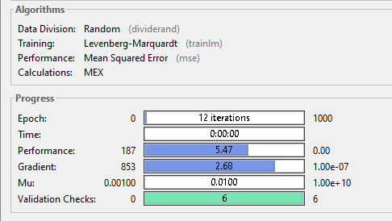

STEP 4: *TO TRAIN THE NEURAL NETWORK*

* Feed the 70% of data to the network which contains both input and target variable.
* Each input maps to an output
* The neural network [NN] , learns the pattern of mapping from input to the output.
* Check the regression line using regression plot map.
* Regression line is 45 degrees inclined to the X axis and most of the data passes through the regression line.
* When the data is trained with all the above conditions, it produces output with accuracy more than 85%(approximately 90%) which is a very good neural network/model.
* If the NN produces less accurate models, then we can train the network by increasing the number of hidden layers.
* 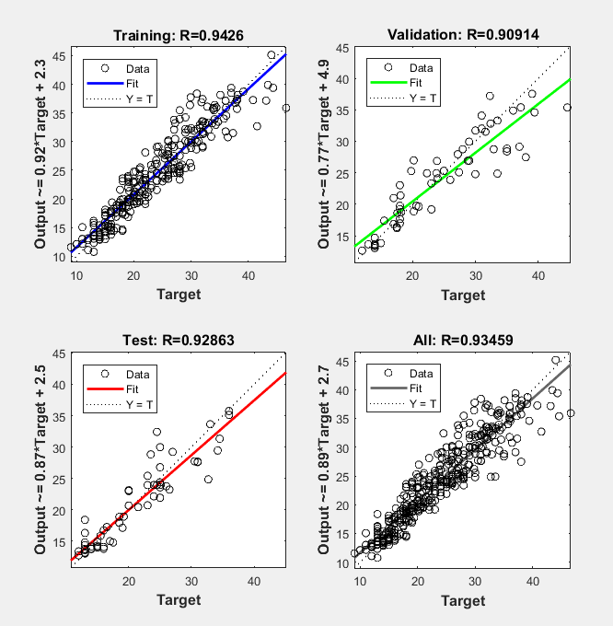

STEP 5: *To TEST THE REMAINING 30% OF DATA*

• Remaining 30% of the data is used for testing.

• For the above mentioned conditions ( no of hidden layers , no of neurons used) when the model is simulated with the remaining data , it produces a result with 94% accuracy.

• The data fits the model with very less errors.

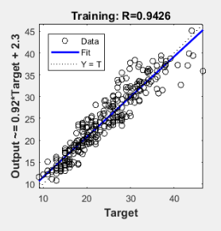

STEP 6: *ERROR CALCULATION*

* Error percentage is calculated by using formula.

Error = (Actual – Expected) / (Actual)

Accuracy = 1- Error